THE UNIVERSITY OF AZAD JAMMU & KASHMIR
DEPARTMENT OF SOFTWARE ENGINEERING

Student Name | Syed Muhammad Hassan Gillani | 
Roll Number | 2024-SE-42
Course Name | Software Construction & Development
Course Code | SE-3101
Session | 2024-2028 (BS SE - 5th Sem)
Department Name | Department of Software Engineering
Task / Assignment No. | Lab Task #03
Instructor Name | Engr. Dr Asma Javed
Submission Date | November 01, 2026
Topic / Title | Sequence Diagrams
Question 1: ATM Cash Withdrawal Sequence Diagram
Problem Description: Model the sequence of interactions and data processing involved when a customer performs a cash withdrawal at an Automated Teller Machine (ATM).
UML Sequence Diagram
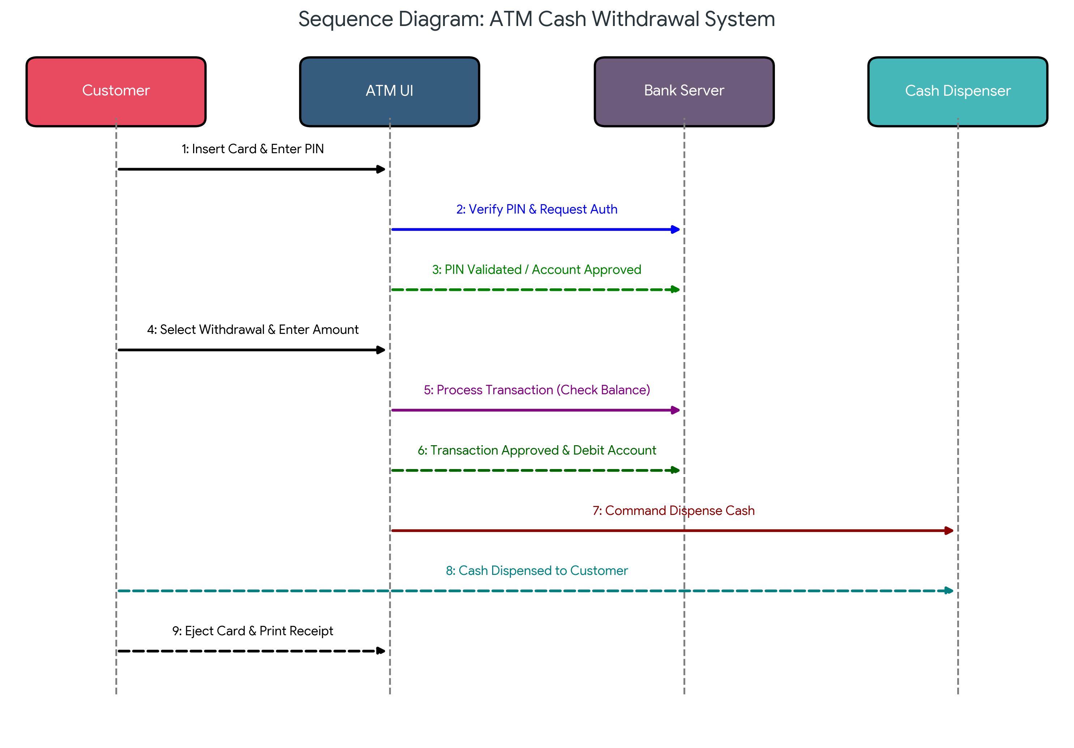
Figure: Sequence Diagram for ATM Cash Withdrawal System
Detailed Workflow & Diagram Explanation
The sequence diagram for the ATM Cash Withdrawal system models the dynamic interactions between four primary objects over time:
- 1. Customer (Actor): The end-user initiating the cash withdrawal transaction.
- 2. ATM UI (Boundary Object): The physical interface/terminal allowing card insertion, PIN input, and screen interactions.
- 3. Bank Server (Control/Core System): The centralized banking server responsible for authentication, debiting accounts, and managing ledger security.
- 4. Cash Dispenser (Hardware Device): The internal mechanical system responsible for delivering physical currency notes.
Step-by-Step Message Execution Sequence:
- Message 1 (Customer -> ATM UI): Customer inserts debit card and inputs their secret PIN.
- Message 2 (ATM UI -> Bank Server): ATM UI forwards card credentials and PIN to the Bank Server for authentication.
- Message 3 (Bank Server -> ATM UI): Bank Server validates credentials and returns an authorization acknowledgment.
- Message 4 (Customer -> ATM UI): Customer selects 'Withdrawal' option and enters the desired withdrawal amount.
- Message 5 (ATM UI -> Bank Server): ATM UI sends transaction request to check ledger balance and daily limit.
- Message 6 (Bank Server -> ATM UI): Bank Server approves transaction and debits the customer's account balance.
- Message 7 (ATM UI -> Cash Dispenser): ATM UI sends a signal to trigger physical cash counting and dispensing.
- Message 8 (Cash Dispenser -> Customer): Cash Dispenser releases currency notes to the customer tray.
- Message 9 (ATM UI -> Customer): ATM UI ejects the bank card, prints transaction receipt, and completes session.
Question 2: Online Ticket Reservation Sequence Diagram
Problem Description: Model the interaction sequence for an online ticket reservation platform, capturing seat selection, temporary locking, payment validation, and e-ticket generation.
UML Sequence Diagram
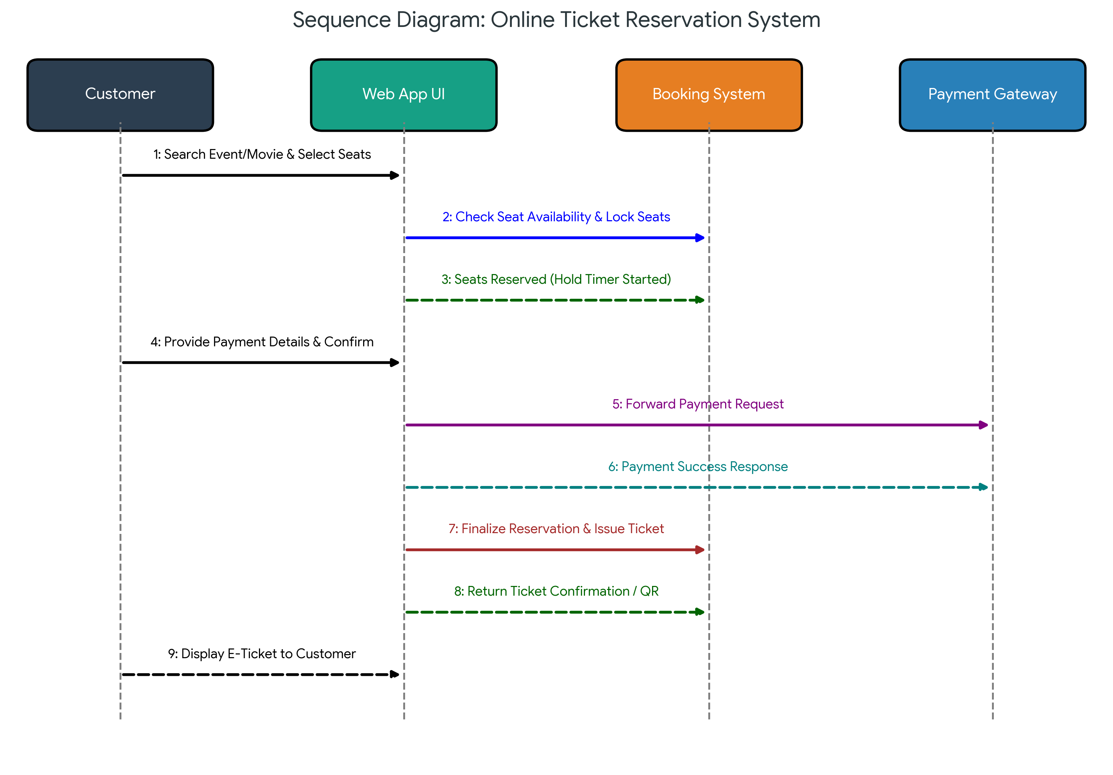
Figure: Sequence Diagram for Online Ticket Reservation System
Detailed Workflow & Diagram Explanation
The sequence diagram represents the end-to-end event ordering required to reserve tickets for events or movies online:
- 1. Customer (Actor): The user booking tickets via mobile app or web portal.
- 2. Web App UI (Boundary Object): The user-facing interface for browsing, seat layout visualization, and payment entry.
- 3. Booking System (Control System): The backend logic handling seat inventory, temporary holds, and booking records.
- 4. Payment Gateway (External Service): The third-party payment processor verifying credit card/banking credentials.
Step-by-Step Message Execution Sequence:
- Message 1 (Customer -> Web App UI): Customer browses events, selects showtime, and chooses specific seat numbers.
- Message 2 (Web App UI -> Booking System): Request sent to reserve selected seats in real time.
- Message 3 (Booking System -> Web App UI): System locks seats temporarily (starts hold timer) and returns confirmation.
- Message 4 (Customer -> Web App UI): Customer inputs payment credentials (credit card/UPI/net banking) and confirms checkout.
- Message 5 (Web App UI -> Payment Gateway): Payment details securely transmitted to Gateway for processing.
- Message 6 (Payment Gateway -> Web App UI): Payment Gateway verifies funds and returns 'Success' payment token.
- Message 7 (Web App UI -> Booking System): UI sends booking completion command to backend.
- Message 8 (Booking System -> Web App UI): Booking System updates status from 'Held' to 'Booked' and generates QR-coded E-Ticket.
- Message 9 (Web App UI -> Customer): Displays confirmed E-Ticket with booking details on customer device.

